Volatility correlation: AUDUSD and USDJPY
Method 25 / daily |log returns| / rho_vol / Alpari D1 full available history (realized deferred)

Study setup
Logical pair: AUDUSD , USDJPY
Broker symbols: AUDUSD_i , USDJPY_i
Snapshot: 2026-11-03_majors_alpari_D1
Timeframe: D1
Matched return window: 1999-01-05 to 2026-11-02 (UTC bar dates)
Matched return count n: 7199
Dropped unfinished last bar dated 2026-11-03 UTC after a tick-volume check against the prior complete day.
Statistic: rho_vol = Corr(|log return_L|, |log return_R|)
rho_realized: not computed (no intraday buckets in this snapshot)
Complete matched rows (Excel): AUDUSD-USDJPY_Vol_D1.xlsx
Complete matched rows (HTML table): AUDUSD-USDJPY_Vol_D1_data.html

Method carried forward
Volatility correlation rho_vol = Corr(|x_t|, |y_t|) measures whether absolute daily log returns of close move together in size, regardless of sign. Quotes are not inverted. Same-sample signed Pearson r is a side check. The formula sheet also defines within-day realized correlation rho_realized,d from intraday buckets; this v001 uses the Alpari D1 snapshot only, so rho_realized is not computed (no intraday buckets). This is not causation and not a trading signal.

Results (headline)
rho_vol: 0.332494
Pearson r (signed): -0.088151
mean |AUDUSD|: 0.00535510
mean |USDJPY|: 0.00444865
rho_realized: n/a (D1-only snapshot)

Conclusion
Headline rho_vol for AUDUSD and USDJPY: 0.3325. Signed Pearson r = -0.0882. Mean |return|: 0.005355 (AUDUSD), 0.004449 (USDJPY). rho_realized not computed (D1 snapshot has no intraday buckets). This is absolute-move co-movement, not a trading signal.

Charts
Daily closes

Daily log returns

Absolute returns scatter
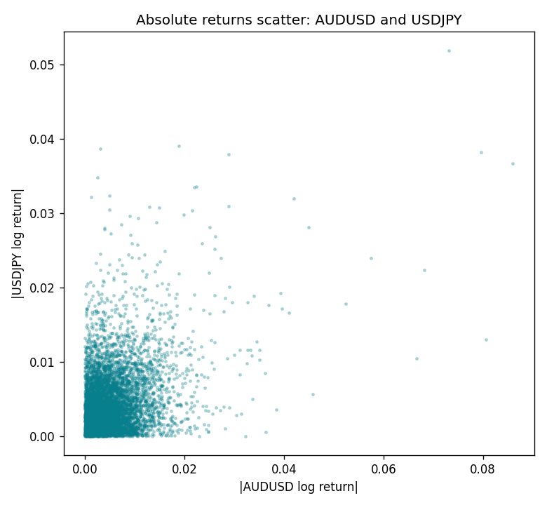

Data report
Matched rows are in the sibling Excel workbook named AUDUSD-USDJPY_Vol_D1.xlsx. Embedding all rows as a Word table is impractical; this file holds column summaries and the first and last 15 matched rows.
Columns: time, AUDUSD_open, USDJPY_open, AUDUSD_high, USDJPY_high, AUDUSD_low, USDJPY_low, AUDUSD_close, USDJPY_close, AUDUSD_tick_volume, USDJPY_tick_volume, AUDUSD_spread, USDJPY_spread, AUDUSD_real_volume, USDJPY_real_volume, AUDUSD_log_return, USDJPY_log_return, AUDUSD_abs_return, USDJPY_abs_return
Column summaries (matched calculation rows)
column | count | mean | std | min | 25% | 50% | 75% | max
AUDUSD_open | 7199 | 0.75196998 | 0.13527571 | 0.4785 | 0.661035 | 0.73142 | 0.809135 | 1.10284
USDJPY_open | 7199 | 113.81114 | 19.206896 | 75.693 | 104.4285 | 110.984 | 120.6925 | 163.824
AUDUSD_high | 7199 | 0.75602148 | 0.13583632 | 0.4878 | 0.6647 | 0.7349 | 0.815325 | 1.10795
USDJPY_high | 7199 | 114.30872 | 19.268446 | 76.001 | 104.881 | 111.442 | 121.26 | 163.978
AUDUSD_low | 7199 | 0.7479145 | 0.13459018 | 0.4775 | 0.6577 | 0.72758 | 0.80425 | 1.0975
USDJPY_low | 7199 | 113.28779 | 19.134887 | 75.402 | 103.89 | 110.53 | 120.17 | 163.628
AUDUSD_close | 7199 | 0.75202255 | 0.13525884 | 0.4786 | 0.661195 | 0.73175 | 0.809235 | 1.10169
USDJPY_close | 7199 | 113.824 | 19.222288 | 75.811 | 104.42 | 111.025 | 120.687 | 163.851
AUDUSD_tick_volume | 7199 | 77366.826 | 138149.99 | 109 | 5440 | 43349 | 71344.5 | 1234623
USDJPY_tick_volume | 7199 | 106151.62 | 179316.41 | 197 | 9927 | 53098 | 92761 | 1803508
AUDUSD_spread | 7199 | 30.814558 | 16.886804 | 0 | 13 | 30 | 50 | 50
USDJPY_spread | 7199 | 20.321434 | 17.631726 | 0 | 6 | 11 | 30 | 50
AUDUSD_real_volume | 7199 | 5.2435469e+09 | 1.2539788e+11 | 0 | 0 | 0 | 0 | 3.811512e+12
USDJPY_real_volume | 7199 | 3.470603e+10 | 1.6078743e+11 | 0 | 0 | 0 | 0 | 3.8834203e+12
AUDUSD_log_return | 7199 | 2.78e-05 | 0.00754502 | -0.08602525 | -0.00385397 | 0.00028846 | 0.00415332 | 0.0806166
USDJPY_log_return | 7199 | 4.761e-05 | 0.00620532 | -0.03908203 | -0.00320306 | 0.00011368 | 0.00340781 | 0.05184024
AUDUSD_abs_return | 7199 | 0.0053551 | 0.00531479 | 0 | 0.0019161 | 0.00399796 | 0.00717628 | 0.08602525
USDJPY_abs_return | 7199 | 0.00444865 | 0.00432609 | 0 | 0.00143294 | 0.0033067 | 0.00619613 | 0.05184024
First 15 matched rows (selected columns)
time | AUDUSD_log_return | USDJPY_log_return | AUDUSD_abs_return | USDJPY_abs_return
1999-01-05 | -0.00080418179 | -0.00017868311 | 0.00080418179 | 0.00017868311
1999-01-06 | 0.011836351 | 0.0075660159 | 0.011836351 | 0.0075660159
1999-01-07 | 0.0088650256 | -0.012851583 | 0.0088650256 | 0.012851583
1999-01-08 | 0.00031515916 | -0.0047719894 | 0.00031515916 | 0.0047719894
1999-01-11 | 0.0072213815 | -0.016195423 | 0.0072213815 | 0.016195423
1999-01-12 | -0.0048608485 | 0.032310364 | 0.0048608485 | 0.032310364
1999-01-13 | -0.0078902098 | 0.0081373171 | 0.0078902098 | 0.0081373171
1999-01-14 | -0.002696916 | 0 | 0.002696916 | 0
1999-01-15 | 0.007123101 | 0.0055343401 | 0.007123101 | 0.0055343401
1999-01-18 | 0.00094592471 | 8.7600193e-05 | 0.00094592471 | 8.7600193e-05
1999-01-19 | 0.0072225153 | -0.0056219403 | 0.0072225153 | 0.0056219403
1999-01-20 | 0.0012507819 | -0.0053879917 | 0.0012507819 | 0.0053879917
1999-01-21 | 0.00078094498 | 0.0084664056 | 0.00078094498 | 0.0084664056
1999-01-22 | -0.012252745 | 0.0060412564 | 0.012252745 | 0.0060412564
1999-01-25 | -0.0039591468 | -0.0073594164 | 0.0039591468 | 0.0073594164
Last 15 matched rows (selected columns)
time | AUDUSD_log_return | USDJPY_log_return | AUDUSD_abs_return | USDJPY_abs_return
2026-10-13 | 0.0035007712 | -0.0018932826 | 0.0035007712 | 0.0018932826
2026-10-14 | -0.0015193215 | 7.5800166e-05 | 0.0015193215 | 7.5800166e-05
2026-10-15 | -0.0075447063 | -0.0018524319 | 0.0075447063 | 0.0018524319
2026-10-16 | 0.0033906408 | -0.00037976126 | 0.0033906408 | 0.00037976126
2026-10-19 | 0.0050859986 | 0.0034946841 | 0.0050859986 | 0.0034946841
2026-10-20 | 0.0034620426 | -0.0022546642 | 0.0034620426 | 0.0022546642
2026-10-21 | 0.0036066384 | -0.00032883504 | 0.0036066384 | 0.00032883504
2026-10-22 | -0.0012672558 | -0.0085942669 | 0.0012672558 | 0.0085942669
2026-10-23 | 0.0023765656 | 0.00035080446 | 0.0023765656 | 0.00035080446
2026-10-26 | -0.0032032829 | 0.0041238746 | 0.0032032829 | 0.0041238746
2026-10-27 | 0.0016669876 | 0.0027651658 | 0.0016669876 | 0.0027651658
2026-10-28 | 0.0040915541 | -0.00095679538 | 0.0040915541 | 0.00095679538
2026-10-29 | -0.0040915541 | -0.00038043789 | 0.0040915541 | 0.00038043789
2026-10-30 | 0.0010102376 | -0.0010596481 | 0.0010102376 | 0.0010596481
2026-11-02 | -0.0049184984 | 0.0026438521 | 0.0049184984 | 0.0026438521

